securing somalia  Readdressing Current Strategy in Combatting Al Shabaab’s Rise in East Africa | Abstract  Addresses the current threat level of Al Shabaab to the American public, and the role the United States must undertake in Somalia’s campaign against the terrorist organization  Jalessa “Jaea” Compton  Bureau of Diplomatic Security US State Department

Current Situation: Al Shabaab’s East African History Since the Mid 2000s
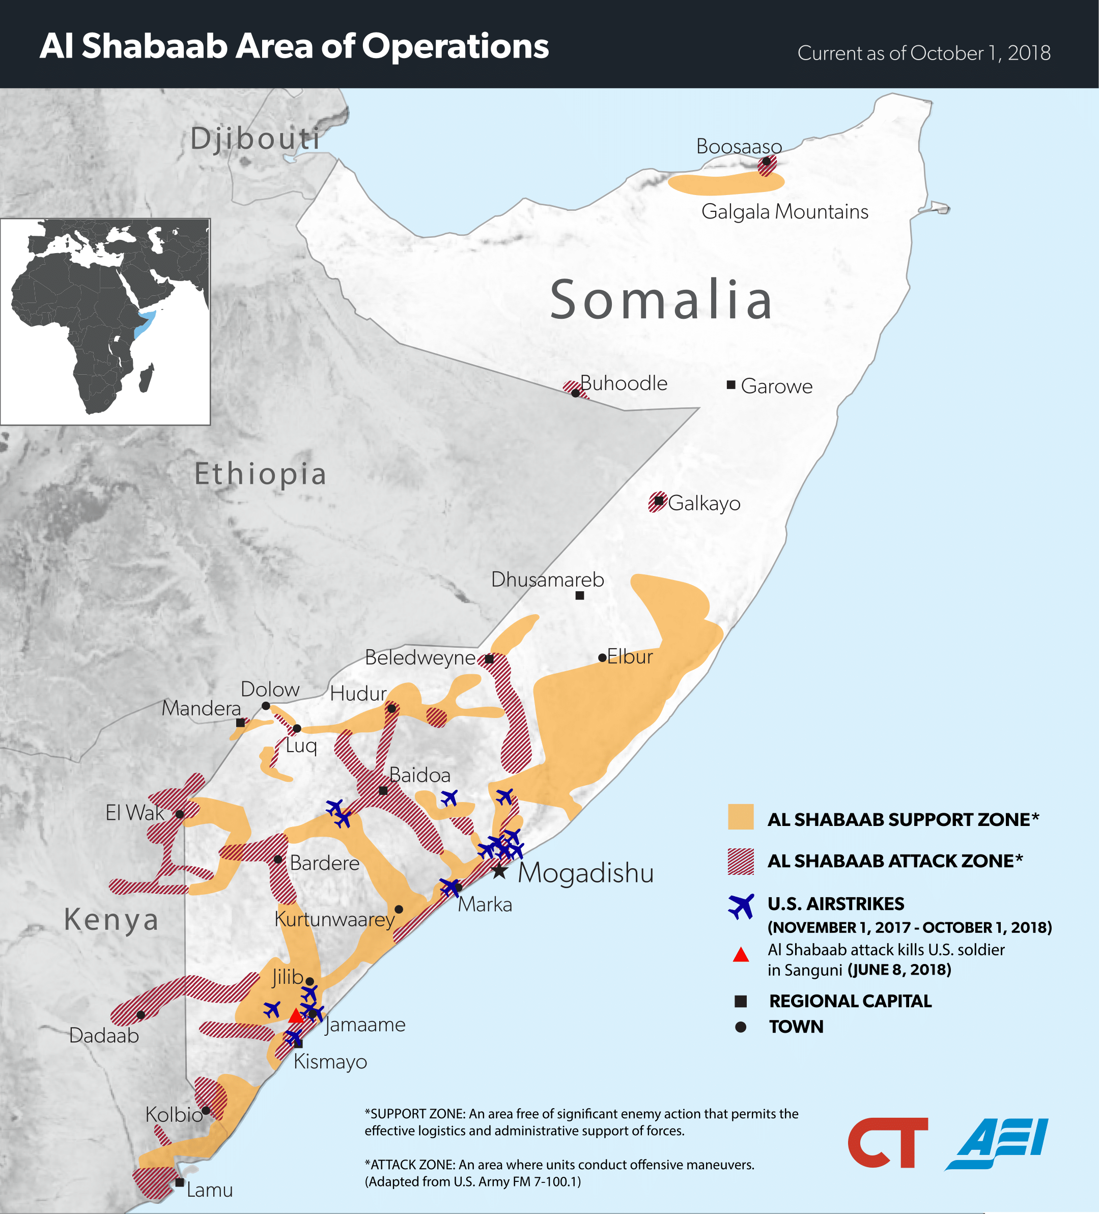
Somalia has faced thirty years of domestic instability and ecologic disasters that threaten to return the nation to a failed state status. Since the fall of Said Barre in 1991, there have been numerous, if not always successful, attempts to reunite Somalia’s regions and clans under a central and legitimate authoritative body capable of providing vital services and security to all Somali populations. It wasn’t until 2012 that a federal government was fully formed with the capability to performing just that, giving regional terror groups easy access to power grabs within Somalia before then. Ethiopian intervention during this time frame caused the Islamic Courts Council (also known as the Islamic Courts Union) to splinter into several smaller organizations. Enter Harakat Shabaab al Mujahidin, founded between 2004 and 2006, as a militant offshoot of the Somali Islamic Courts Council..
Al Shabaab presents itself as the nationalistic and resistant governmental alternative to the current Somali government in place and backed by Western-led countries. Since the movement is decentralized, several other driving influences make up the manifesto of the movement: advancing the cause of international jihad, uniting ethnic Somali inhabited areas of Kenya, Ethiopia, Djibouti, and Somalia under an Islamist government, and retaliation against Ethiopia, Kenya, Uganda, and other AMISON (African Union Mission in Somalia) affiliated countries violating the sovereignty of Somalia. In 2008, the United States formally declared Al Shabaab a terrorist organization.
Up until 2012, Al Shabaab served as the strongest, best organized, financed, and armed military group within Somalia, and controlled the largest territory, mainly in Southern Somalia. Pushback from AMISON, including taking back Mogadishu capitol of Somalia from the terrorist stronghold, as well as Kismayo, Merka, and Baraawe, revenue generator port cities for the terrorist organization has greatly weakened the capabilities of Al Shabaab, but the group has now turned from militant action and attacks to asymmetric warfare. Al Shabaab still controls large stretches of rural territories, and funding from illegal charcoal production and export. Allegedly, revenue is also generated through wired contributions from the Somali diaspora.

United States Threat? Al Shabaab’s Current and Developing Capabilities
While Al Shabaab may not seem a direct threat to the United States, there are several alarming trends regarding the group’s regional and international affiliations, recruitment tactics, targeted attacks, and regional destabilization efforts that are of concern to the United States.
Affiliation:
In 2010, then leader of Al Shabaab Ahmed Abdi Godane pledged allegiance to Al Qaeda, and formalized an agreement between the two organizations in 2012. Al Qaeda has already successfully carried out attacks on United States soil, and the current leader of the movement Ayman al-Zawahiri continues to publicly call for supporters and affiliates to attract jihadists and attack the U.S. government and its citizens globally. It has been hypothesized that becoming aligned with the international Al Qaeda movement was one means of raising Al Shabaab’s international profile, as well as a partnership to assist with jihad beyond the borders of Somalia.
According to a report by a senior military commander in the region, Al Shabaab, Al Qaeda in the Islamic Maghreb, and Boko Haram have attempted to form a transnational alliance of convenience, with one of the purposes being to coordinate attacks against the United States as well as other “Western” targets. Al Shabaab has also been successful in coordinating with smaller regional terror groups, such as Kenya’s Al Hijira to coordinate attacks on United States interests within East Africa.
These trends are alarming, as a standalone Al Shabaab does not have the capabilities to financially or logistically carry out any terroristic activities within the United States. But with partnerships with local and international terror organizations, we realize not only is the group willing to work symbiotically with others who may not share their beliefs if only for the end goal of the mission at hand, but shared resources and intel between terror organizations increases the chances of Al Shabaab and like partners successfully carrying out a terrorist attack on American soil. But this is not the only concern of the United States, as Al Shabaab has a successful history of radicalization and recruitment within our borders.
Radicalization:
The true number unknown, there are several public cases of Al Shabaab recruiting Somali Americans to fight in the region, including leadership such as Alabama-born Abu Mansoor al-Amriki, a commander for Al Shabaab. Peter King, Congressman and former chair of the House Committee of Homeland Security in 2011 curated a report that alleges 40 Muslim Americans and 20 Canadian Americans have been recruited to fight on behalf of Al Shabaab. His fear, is that this statistic may be a lowball, and other recruited members may have been able to return to the United States, radicalized and undetected. What is known for sure is at least two operations, code named Minneapolis 8 and Toronto 6 focused on indoctrinating Somali Americans to return to their homeland and fight for the jihad.
While in the eight years past this report we have not had an Al Shabaab claimed terrorist attack on United States soil, it is not outside the realm of possibilities, as Al Shabaab is continually changing their strategy, and any successful operation of American soil would further their prestige with regional and international terrorism partners. In 2015, the group released a video encouraging attacks in Kenya and abroad, naming several shopping malls in Europe and the United States as potential targets, including Minnesota’s Mall of America. A radicalized American citizen requires little organizational costs or ground support to complete such an act.
Also, like ISIL, Al Shabaab relies heavily on social media to recruit and radicalize Somali youth. The organization has an active presence on Facebook, Twitter, YouTube, and utilizes more mainstream avenues such as websites and radio. According to the United Nation’s Assistance Mission in Somalia’s focus group report, Al Shabaab is regarded as savvy and eloquent, and their pre-recorded videos of suicide attackers having lavish lifestyles before initiating attacks is seen as so persuasive, youth involved in the study suggested the government restrict Al Shabaab’s access to social media, and called out the international community and media for giving the terrorist organization a platform to begin with.
Social media does not stop at the Somali border. Ideology does not stop at the Somali border. As at least two terrorist attacks in ISIL’s name have been carried out by radicalized American residents and citizens upon the United States, future social media radicalization of a United States citizen in the name of Al Shabaab should be and is a continual concern.
Destabilization:
As stated previously within the memo, one of the aims of Al Shabaab is uniting ethnic Somali inhabited areas of Kenya, Ethiopia, Djibouti, and Somalia under an Islamist government. The terrorist organization has been successful in carrying out attacks on U.S. interests within East Africa, especially within Kenya, one of our strongest regional security and economic partners. This year alone, Al Shabaab thrice bombed policemen at the Kenyan-Somali border, attacked a US drone base and European military convoy, murdered the mayor of Mogadishu who was a naturalized British citizen, attacked a government building within Somalia, and attacked a central city hotel in Kismayo.
Each of these acts fractures the Somali government’s ability to focus on stabilizing security within the nation, exacerbating the current security issues of having porous borders where terror agents can come and leave as they please, to recruit abroad or carry supplies back and forth to sustain illegal operations. With most of Somalia’s government efforts focusing on internal security, the economic and humanitarian needs of the nation fall by the wayside, giving Al Shabaab recruitment a boost in disgruntled and underemployed citizens, looking for means to support their families.
Al Shabaab’s Kenyan and Ugandan activities include the 2010 World Cup suicide bombing in Kampala, kidnapping international aid workers in 2011 from Kenya, multiple day siege of Westgate Mall in Nairobi in 2013, raiding Kenya’s Garissa University College two years later, ambushing a Kenyan AMISOM base in 2016, and a failed suicide bombing via aircraft attempt that same year. Even more terrifying for Kenya, the Westgate Mall attack was a collaborative effort between Al Hijira, Kenya’s local terror organization and Al Shabaab.
Our national partnership with Kenya is key for promoting East African relations; Nairobi serves as the economic hub of East Africa, where several major US corporations such as IBM and GE retain regional offices. Our embassy within Nairobi is our largest on the continent, and the management headquarters for regional assistance programs and counterterrorism capabilities for Kenya worth billions of dollars. If operations are indeed disrupted by terrorism activity, this would be a substantive financial loss to both Kenya and the United States.
If Al Shabaab is successful in destabilizing Somalia into a failed state system again, there is a possibility destabilization will spread into Kenya and surrounding nations. A destabilized Kenya puts US interests and investments at risk, at a time where the relationship between the two nations is already strained.

Current Options: Somalia’s Terrorism Problem and Hypothesized Solutions
Withdrawing US Troops
Al Shabaab is not a pressing or immediate threat to United States’ national security. It may be a threat to our East African interests, but no direct actions have been taken against the continental United States. Withdrawing troops from the region and allowing AMISOM and the Somali forces to complete the mission of fighting Al Shabaab will aid in winning back perceived governmental legitimacy in the eyes of the Somali people. In the United Nation’s Assistance Mission in Somalia’s focus group report, participants labeled Somali leaders as “selfish practitioners of corruption and nepotism who are subject to foreign influences.” Their expressed views regarding the current government stated they viewed the government as week with poor governance structures and ineffective critical institutions. Allowing the Somali government to either regain control without international assistance or collapse within itself may encourage and improve national perception and public engagement (as a preventative measure in the case of near government collapse) within Somalia. The Somali consensus that the United States is fighting for personal interests may be hindering trust in current Somali governance.
Potential Outcome Advantages
By withdrawing we concede to one of Al Shabaab’s demands, opening the door for negotiations. We also lessen our chances of being an eventual continental target. It is probable to assume the American public will support this initiative. Despite the wave of backlash experienced when the current executive administration announced withdrawal of troops from Syria, there seem to currently be no current political repercussions. As Pretty Prudent Public theory states:
“Public support for use of military force varies based on perceptions of what the principal policy objective was, with three general trends. Public support tends to be greatest when the principal policy objective is to coerce foreign policy restraint of an aggressor threatening the United States, its citizens, or its interests; lowest when the principal objective is to engineer internal political change in another country’s government; and in between for humanitarian interventions. While casualties decrease support, they do so with some differentiation based on the principal policy objectives. The public is most willing to sustain support, even with relatively high numbers of casualties, when force is being used for foreign policy restraint; casualties present a hindrance to public support in cases of humanitarian intervention, and an even greater hindrance in cases of internal political change.”
Potential Outcome Disadvantages
Without United States training and assistance, it is very possible that Al Shabaab will increase their military insurgence, and reclaim even more territory than previously held, continuing the current stalemate and threatening the security of border states such as Kenya. Without a foreign presence, AMISOM may also continue their human rights abuse campaign of scorched earth, leading to an increase in Somali refugees, a burden not only to the United States, but immediate border nations of Somalia.

Assist in Initiating Peace Negotiations/Power Share
In lieu of reliance on foreign military intervention, it may now be the time to consider peace negotiations with Al Shabaab rather than continue the tug-of-war of recapturing and relinquishing territory of the organization. As pointed out by Dr. Afyare Abdi Elmi and Avdi Aynte of Al Jazeera Center for Studies, neither Al Shabaab nor the current government of Somalia, even with international assistance, has the capability to win the current war militarily.
While it is in Somalia’s best interest that another neutral nation respected by the Somali government, Somali citizens, and Al Shabaab should initiate and facilitate any peace or power share negotiations, the United States should publicly throw full and financial support behind Somalia in the pursual of peace.
Potential Outcome Advantages
Government legitimacy in the eyes of the Somali people would be one of the greatest advantages to pursuing peace talks, as many citizens view the current fighting as political and rehashed civil war grievances. Negotiations have the added benefit of figuring out the BATNA (Best Alternative for the Negotiation Treaty) of Al Shabaab leadership, so if all talks fail, Somalia can strategize how best to use Al Shabaab’s greatest requests as a military strategy and leverage. And an end to fighting Al Shabaab gives the Somali government time and resources to invest in state building and to create and fortify critical infrastructures.
Potential Outcome Disadvantages
More extremist members of Al Shabaab may see peace talks as anti-jihad and ramp up asymmetrical attacks against critical Somali infrastructures. If the international community does not support the ideas of peace talks, there will not be enough pressure to hold Somalia’s feet to the fire, and the campaign against the terrorist organization may drag on senselessly.

Path Forwards: Securing Somalia
Al Shabaab and Somalia have reached a “mutually hurting stalemate.” There is not much hope for an end to this war, as for thirty years now Islamist groups have used force and campaigns to attempt regime change. After every defeat, the groups reorganized and changed strategies, leaving Somalia with its current resilient and adaptive enemy of Al Shabaab. And while it may be a personal wish of the author that the strategy of peace talks is attempted, Ethiopian and AMISOM objection to this proposal nixes peace negotiations or power share as an immediately viable option. Peace talks have been on the table since the beginning of Al Shabaab’s military aggression, however a serious plan to engage the terrorist organization has never surfaced.
We must withdraw American troops. It is not a financial cost or human capital burden American citizens should have to bear, as it is not currently an American war. With unintended Somali civilian casualties due to bad intelligence regarding drone strikes, we are feeding into the narrative Al Shabaab projects regarding the evils of international and Western intervention. If Somalia is to fall into failed state status again, it is best that we provide humanitarian aid through NGOs and minimal USAID fronted organizations, and not to intervene in government stabilization or any military peacekeeping.
To best protect American interests, we must focus our attention on Kenya’s counterterrorism and policing training, in preparation of the slowly growing Islamic insurgency movement. There, American interests are actually at risk, and with terrorism activity seeping over the Somali border it seems the American embassy and corporations in operation would be the easiest targets for Al Shabaab to attack in retaliation for our current presence in Somalia. The American public would be more likely to support a campaign of protecting American interests in Kenya over regime protection in Somalia according to the Pretty Prudent Public Theory, and lastly leaving Somalia is an “end” of another endless terrorism war.

Works Cited

“Al-Shabaab | World News: The Latest News and Comment on Al-Shabaab.” The Guardian, Guardian News and Media, www.theguardian.com/world/al-shabaab.
Barnett, James. “Al Shabaab Area of Operation (Graphic.)” Critical Threats, Oct. 2018, www.criticalthreats.org/analysis/al-shabaab-area-of-operations-october-2018.
Blanchard, Lauren, and Katherine Terrell. “Al Shabaab.” Congressional Research Service, 6 Nov. 2017, crsreports.congress.gov/product/pdf/IF/IF10155.

Blanchard, Lauren. “Somalia.” Congressional Research Service, 10 Apr. 2019, crsreports.congress.gov/product/pdf/IF/IF10155.

“Countering Al-Shabaab Propaganda and Recruitment Mechanisms in South Centra Somalia.” United Nations Assistance Mission in Somalia, UNSOM, Aug. 2017, unsom.unmissions.org/sites/default/files/countering_al-shabaab_propaganda_and_recruitment_mechanisms_report_final_-_14_august_2017.pdf.

“Country Reports on Terrorism 2017 - United States Department of State.” U.S. Department of State, U.S. Department of State, Sept. 2018, www.state.gov/reports/country-reports-on-terrorism-2017/.

Dowd, Robert A. “Violent Religious Extremism and U.S.–Africa Policy.” The Review of Faith & International Affairs, vol. 14, no. 2, 2016, pp. 93–100., doi:10.1080/15570274.2016.1184441.

Downie, Richard. “Al-Shabaab: How Great a Threat.” Al-Shabaab: How Great a Threat | Center for Strategic and International Studies, Center for Strategic & International Studies, 3 Oct. 2013, www.csis.org/analysis/al-shabaab-how-great-threat.

Elmi, Afyare, and Abdi Aynte. “The Case for Negotiating with Al-Shabaab.” Al Jazeera Center for Studies, 16 Jan. 2012, doi:10.13140/RG.2.2.19612.08324.

Jentleson, Bruce. American Foreign Policy: The Dynamics of Choice in the 21st Century. 5th ed., W. W. Norton & Company, 2014.
Pelofsky, Jeremy. “Al Shabaab Recruited Dozens of Americans: U.S. Report.” Reuters, Thomson Reuters, 27 July 2011, www.reuters.com/article/us-usa-security-somalia/al-shabaab-recruited-dozens-of-americans-u-s-report-idUSTRE76Q58M20110727.
Roque, Paula. “Somalia: Understanding Al-Shabaab.” Institute for Security Studies, 3 June 2009,
issafrica.org/research/situation-reports/situation-report-somalia-understanding-al-shabaab-paula-cristina-roque.

Tase, Peter. “Terrorism, War and Conflict, an Analysis into the Horn of Africa - Al Shabaab in Somalia; US and UN Efforts to Reduce Violence.” Academicus International Scientific Journal, vol. 7, 2013, pp. 27–35., doi:10.7336/academicus.2013.07.03.

“Somalia” Congressional Research Services, paraphrased
“Terrorism, War and Conflict, An Analysis into the Horn of Africa” Peter Tase, International Scientific Journal
“Country Reports on Terrorism 2017” Department of State Bureau of Counterterrorism
“Violent Religious Extremism and U.S.-Africa Policy” Robert Dowd, The Review of Faith & International Affairs
“Al Shabaab: How Great a Threat?” Richard Downie, Center for Strategic & International Studies
“Al Shabaab: How Great a Threat?” Richard Downie, Center for Strategic & International Studies
“Al Shabaab” Congressional Research Service
“Al Shabaab” Congressional Research Service
“Al Shabaab: How Great at Threat?” Richard Downie, Center for Strategic & International Studies
“Somalia: Understanding Al Shabaab” Paula Roque, Institute for Security Studies
“Somalia: Understanding Al Shabaab” Paula Roque, Institute for Security Studies
“Country Reports on Terrorism 2017” Department of State Bureau of Counterterrorism
“Country Reports on Terrorism 2017” Department of State Bureau of Counterterrorism
“Al Shabaab: How Great a Threat?” Richard Downie, Center for Strategic & International Studies
“Terrorism, War and Conflict, An Analysis into the Horn of Africa” Peter Tase, International Scientific Journal
“Country Reports on Terrorism 2017” Department of State Bureau of Counterterrorism
“Terrorism, War and Conflict, An Analysis into the Horn of Africa” Peter Tase, International Scientific Journal
“Terrorism, War and Conflict, An Analysis into the Horn of Africa” Peter Tase, International Scientific Journal
“Terrorism, War and Conflict, An Analysis into the Horn of Africa” Peter Tase, International Scientific Journal
“Al Shabaab: How Great a Threat?” Richard Downie, Center for Strategic & International Studies
“Al Shabaab recruited dozens of Americans: U.S. report” Jeremy Pelofsky, Reuters
“Terrorism, War and Conflict, An Analysis into the Horn of Africa” Peter Tase, International Scientific Journal
“Al Shabaab” Congressional Research Services
“Countering Al-Shabaab’s Propaganda and Recruitment Mechanisms in South Central Somalia” United Nations Assistance Mission in Somalia
“Al Shabaab: Latest News and Comments” The Guardian
“Country Reports on Terrorism 2017” Department of State Bureau of Counterterrorism
“Al Shabaab: How Great a Threat?” Richard Downie, Center for Strategic & International Studies
“Al Shabaab: How Great a Threat?” Richard Downie, Center for Strategic & International Studies
“Al Shabaab: How Great a Threat?” Richard Downie, Center for Strategic & International Studies
“Al Shabaab: How Great a Threat?” Richard Downie, Center for Strategic & International Studies
“Countering Al-Shabaab’s Propaganda and Recruitment Mechanisms in South Central Somalia” United Nations Assistance Mission in Somalia
“Countering Al-Shabaab’s Propaganda and Recruitment Mechanisms in South Central Somalia” United Nations Assistance Mission in Somalia
“The Case for Negotiating With al-Shabaab” Dr. Afyare Abdi Elmi and Abdi Aynte, Al Jazeera Center for Studies
“American Foreign Policy: The Dynamics of Choice in the 21st Century”
“The Case for Negotiating With al-Shabaab” Dr. Afyare Abdi Elmi and Abdi Aynte, Al Jazeera Center for Studies
“Violent Religious Extremism and U.S.-Africa Policy” Robert Dowd, The Review of Faith & International Affairs
“The Case for Negotiating With al-Shabaab” Dr. Afyare Abdi Elmi and Abdi Aynte, Al Jazeera Center for Studies
“The Case for Negotiating With al-Shabaab” Dr. Afyare Abdi Elmi and Abdi Aynte, Al Jazeera Center for Studies
“The Case for Negotiating With al-Shabaab” Dr. Afyare Abdi Elmi and Abdi Aynte, Al Jazeera Center for Studies
“The Case for Negotiating With al-Shabaab” Dr. Afyare Abdi Elmi and Abdi Aynte, Al Jazeera Center for Studies
“The Case for Negotiating With al-Shabaab” Dr. Afyare Abdi Elmi and Abdi Aynte, Al Jazeera Center for Studies
“The Case for Negotiating With al-Shabaab” Dr. Afyare Abdi Elmi and Abdi Aynte, Al Jazeera Center for Studies
“Al Shabaab: How Great a Threat?” Richard Downie, Center for Strategic & International Studies

