**Evaluation Proposal to Govern the Design of OECS Regional Partnership Strategy**

**Phase II: Social Protections Programs Strategy**

J. H. Compton

Monitoring and Evaluation

Prof. Jenny Gold

05.05.34

1. **Background and Context of Evaluation: OECS Social Protections (Safety Net) Programs**

The Organisation of Eastern Caribbean States (OECS) consists of eleven member states along the Lesser Antilles of the Caribbean. The countries that comprise OECS are Antigua and Barbuda, Commonwealth of Dominica, Grenada, Montserrat, Saint Kitts and Nevis, Saint Lucia, Saint Vincent and The Grenadines, British Virgin Islands, Anguilla, Martinique, and Guadeloupe (OECS, 2020). In 2009, a regional survey determined a high vulnerability to climate and economic shock could be traced to education outcomes (literacy rates), health outcomes (malnutrition), and limited social protections amongst member states (Williams et al., 2013).

The OECS 2010-2014 strategy and subsequent 2015-2019 strategy in collaboration with The World Bank included three outcomes to mitigate the effects of poor health and education as well as access to safety nets (World Bank, 2010) (World Bank a, 2014)

* **Outcome 6**: Improved targeting and reduced fragmentation of social protection systems
* **Outcome 7:** Establishment of quality education standards
* **Outcome 8:** Enhanced data to support evidence-based health policy to address non-communicable diseases

Between 2010-2019, four member states initiated interventions to improve social protections, health outcomes, and education outcomes: St. Lucia (World Bank, 2012) (World Bank b, 2014), St. Vincent and the Grenadines Raudales & Roccio, 2023), Grenada (World Bank, 2019), and Antigua and Barbuda (IEG Review Team, 2018). The components of each country’s program were similar in nature.

* **Component 1:** Improving the delivery mechanism for Conditional Cash Transfers. This component focused on consolidating fragmented cash transfer program’s financing to improve coverage, and the adoption of beneficiary responsibilities to continue receiving cash transfer benefits. Beneficiaries of education-based cash transfers were required to ensure children retained attendance rates of on average (per country) 90% , and health beneficiaries were required to attend preventative health services that aligned with their categorization under the program (i.e., pregnant or nursing parent, elderly, disabled, or chronically ill) (World Bank, 2019).
* **Component 2:** Improving the Implementation Capacity of the government and implementing ministries. This component’s focus was to upskill the government ministries through knowledge transfer and technical assistance in establishing management, coordination, supervision, and monitoring and evaluation of the CCT program at the localized level (World Bank, 2019).

End of evaluation results for these programs have been mixed overall, from partial success in Grenada, after entirely leaving out a pathway to achieve Outcomes 7 and 8 (World Bank, 2019) to unsuccessful in St. Lucia’s attempts to streamline their social protection programs in 2014 (World Bank b) and Antigua and Barbuda also completing little actual progress in strengthening their social protection systems (IEG Review Team, 2018). Moreso, after Grenada completed their information management system, St. Lucia adopted the same framework (Grenada Broadcasting Network, 2019). St. Vincent and the Grenadines is currently still implementing their project started in 2017, however the implementation status report is leaning towards moderately satisfaction and eventual satisfactory completion of the human development project’s second component to strengthen the social protection delivery service of the country(Raudales & Roccio, 2023).

Most projects cited difficulties in data collection for chosen indicators, slow implementation of activities due to governance changes, slow legislation movement, government staff training, and the lack of monitoring and evaluation (World Bank, 2019) (IEG Review Team, 2018).

1. 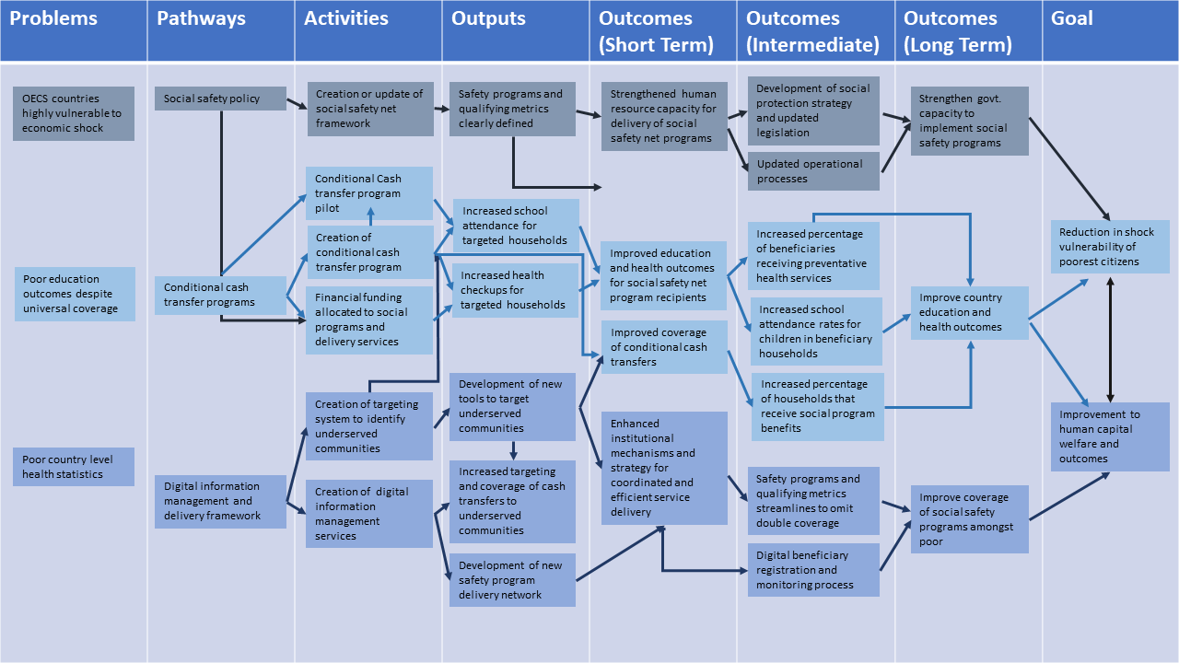**Evaluation Theory of Change**

Overall improvement to OECS human capital’s shock resilience (health and education) outcomes were based on three distinct pathways.

* **Pathway 1:** Social Safety Net Policy. If strengthened government capacity to implement social safety programs is achieved, then there will be development of social protection policy and updated legislation and updated operational processes. This will lead to strengthened human resource capacity to deliver social safety net programs, safety programs and qualifying metrics being clearly defined, and the overall creation and updating of social safety net framework for each country (World Bank, 2019). Assumptions include clear passage of safety net legislation.
* **Pathway 2:** CCT. If improved health and education outcomes are achieved, then an increased percentage of CCT beneficiaries would receive preventative care services, overall social program benefits, as well as attain higher attendance rate in primary and secondary enrolled household members. This will lead to improved overall health outcomes for CCT recipients through increased health checks as condition for receiving CCT, improved education outcomes through the attendance and enrollment conditions, as well as dedicated funding provided by the country’s government to implement CCT programming as a social safety net. (World Bank, 2019).
* **Pathway 3:** Digital information management and delivery framework. If there is an improvement in coverage of social safety programs for the poor, then the creation of a digital beneficiary registration and monitoring program would be implemented and streamlined to minimize double coverage which in turn will allow for greater coverage. There will be a subsequent enhancement in institutional mechanisms and strategies for coordinated an efficient service delivery, development of tools to target the underserved communities which will lead to increased targeting and coverage and development of a new or updated safety program delivery network (World Bank, 2019). Assumptions include government readiness to integrate digital information systems.

1. **Purpose, Objectives, and Audience**

The purpose of this evaluation is to assess the relevance, implementation, and effectiveness of OECS social safety net interventions regionally, before upscaling the program for full regional integration.

From this evaluation, the objective is to glean lessons and best practices are to be garnered to inform the next iteration of OECS Regionally Strategy’s social safety net outcomes goals, as well as Phase II of safety net program interventions within the region.

The audience of this evaluation is OECS’s Council of Ministers and Economic Affairs Council (OECS, 2022). The World Bank is a secondary audience for this evaluation, as the financing and program implementation partner for all four countries participating in establishing and strengthening social protection programs.

1. **Evaluation Questions and Scope**

As health and education conditionalities are tied to country conditional cash transfer programs, yet the ending project glosses over whether or not these conditionalities are improving overall health and education outcomes, the overarching questions of this evaluation seeks to determine the extent of correlation between the conditionalities and improved outcomes. The results from these questions should further guide the design and implementation of Phase II of strengthening social protection programs amongst OECS states.

* **Question 1:** To what extent are conditional cash transfer programs contributing to improved rates of upper secondary education enrollment and overall health outcomes?
* **Question 2:** Are the regionally chosen indicators for measuring education and health outcome improvements in relation to conditional cash transfer recipients the correct ones for determining impact?
* **Question 3:** How successfully has the digital information system for managing conditional cash transfer targeting and monitoring of recipients been implemented regionally?

The scope of this project is OECS initiated projects with social safety net components implemented since the results of the human vulnerability survey was compiled and shared in 2009, until the end of the OECS last recorded regional strategy which ended in 2019.

Conceptually, the scope relies on the assumption that within OECS countries, by attaching education and health conditionalities to cash transfers, a country can see aggregate improvements within health and education outcomes. This evaluation then will only focus on analyzing the conditional cash transfer programs, the education and health conditionalities attached to the conditional cash transfer programs, and the utilization of digital information systems to target beneficiaries and deliver program services. These components directly align with all countries’ social protection programs that fall within the 2010-2019 time frame directed by the scope.

1. 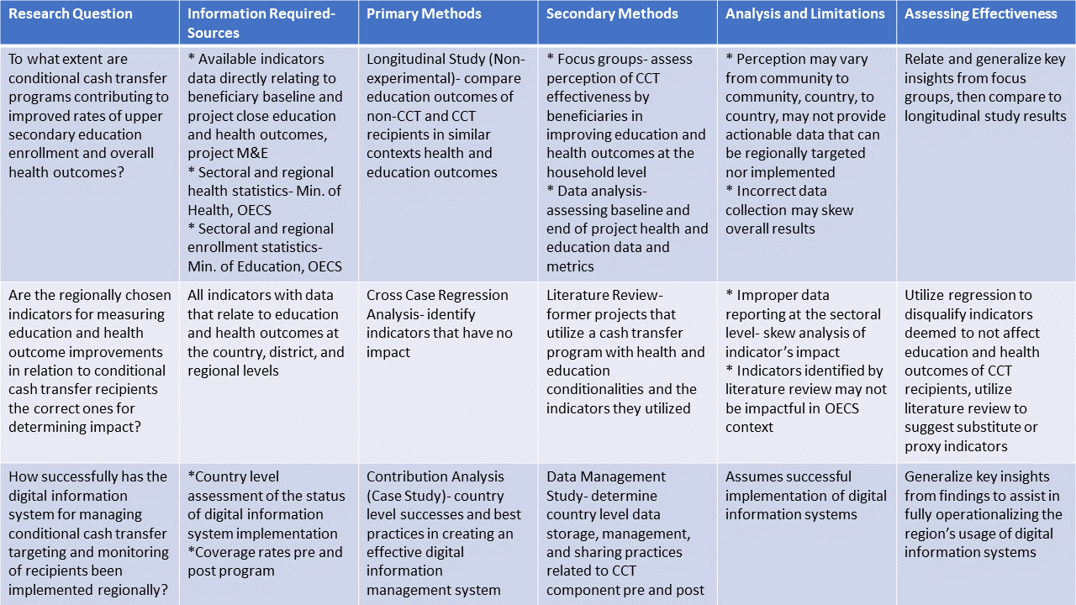**Evaluation Design Matrix**
2. 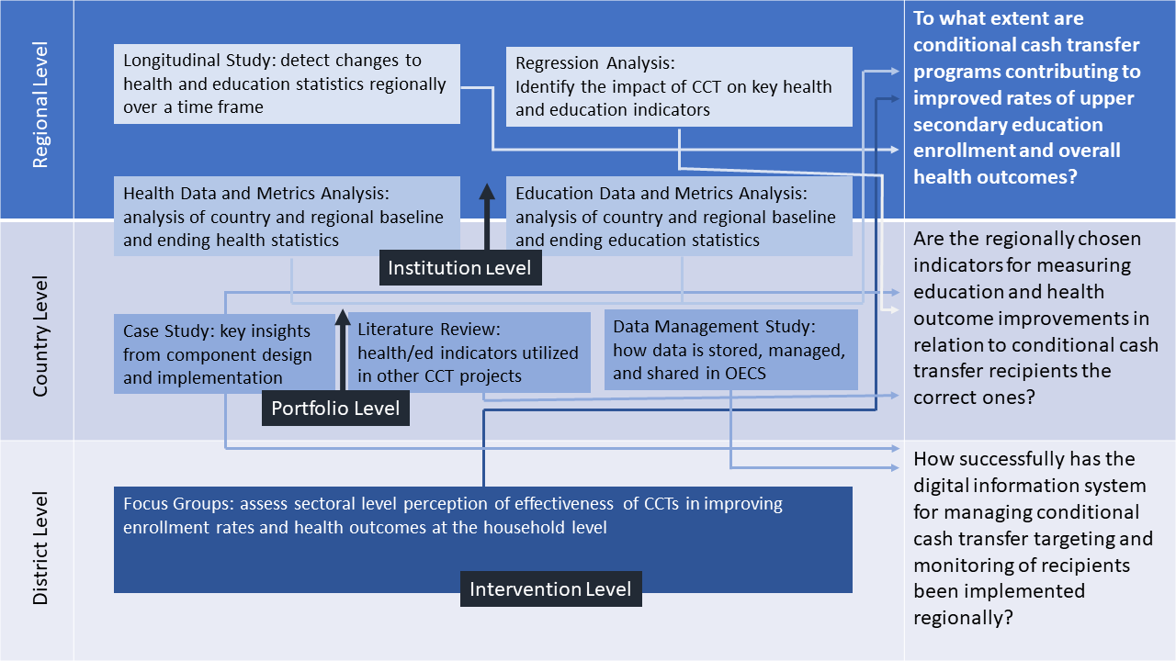**Evaluation Design Diagram**
3. **Description of Evaluation Design and Methods**

The design and methodology of this evaluation will include multilevel analysis at the regional, country, and district levels, utilizing mixed methods. The guiding principles for the evaluation design are country centric case analysis, participatory input from key stakeholders, and beneficiary feedback.

* **Case Based:** Reviewing literature from each country is a majority component of this evaluation’s methodology. Due to the next phase of regional social safety net programs commencing within a ten-month time frame, country level analysis will provide the most efficient analysis of best practices that could be utilized in designing Phase II.
* **Participatory:** This evaluation proposal involved the input of OECS Council of Ministers, the World Bank, as well as ministers within each of the four countries whose programs are in the evaluation. Consulted entities contributed to targeting the key components in which the evaluation learnings can contribute to designing Phase II of social protection programs.
* **Beneficiary Feedback:** Without the buy-in of the primary stakeholders, the recipients of conditional cash transfers and persons who interact with the digital information systems within OECS countries, the success rate of program implementation. The feedback from beneficiaries through proposed focus groups assists with not only determining the technical glitches within the information systems and delivery of cash transfers but provides key insights on how to ensure the systems work most efficiently for both governments and recipients.

As the OECS provides regional data sets, longitudinal studies and regression analyses can be completed at this level.

* **Longitudinal Study:** OECS health and education metrics will be analyzed between 2010-2019, with spikes to be expected following the years of conditional cash transfer policy updates and the integration of digital information systems. The limitation of this method is it cannot exclude variables, contributing to exogenous error in findings. This can be mitigated if findings from longitudinal study are integrated with findings from regression analysis.
* **Regression Analysis:** OECS health and education metrics will be analyzed to determine whether a strong or weak correlation exists between conditional cash transfers and health and education indicators respectively. The limitation of this methodology is that it operates under the assumption that regionally collected data is valid. But when comparing regression analysis findings with the findings of the longitudinal study, key indicators that appear to be most impactful in determining the effects of CCT on health and education outcomes will appear.

Case studies, literature review, and an overall country level data management survey will be implemented at the country level.

* **Case Study:** A case study that aggregates the lessons and best practices from each of the four social protection programs being analyzed by this evaluation will provide key insights for mitigating design, implantation, monitoring, and evaluation pitfalls that occurred for most projects. The limitation of narrowing the scope to these four countries is the limited amount of actionable findings the study may produce, however, when combined with the literature review, more robust and in depth analysis of findings can be undertaken.
* **Literature Review:** the literature review will review available evidences for strong indicators that measure whether CCT are impactful in improving health and education outcomes for a country overall, when health and education based conditionalities are attached to the transfer. Literature and data from countries of a similar economic, education, and heath metrics will be consulted. The limitation of this method is that similar context does not equate to success in determining impactful indicators for OECS regional members specifically. Combined with the findings from the country case study,
* **Data Management Survey:** Due to most countries experiencing difficulties in providing indicator data for analysis, a review of each country’s collection, storage, management, and distribution of raw data will be analyzed, to determine data management is the culprit in poor data collection and distribution for key indicators, or if the fault lies in the indicators themselves.

At the district level, focus groups will give information regarding the perception of conditional cash transfer services as well as the digital information system.

* **Focus Group:** District level focus groups in each of the four countries will be conducted. Participants will be asked their perception of the relevance, efficiency, and effectiveness of the CCT programs overall, relevance, efficiency, and effectiveness of utilizing the digital information services, and the relevance, efficiency, and effectiveness of the conditionality components on health and education levels within their households. The limitation of focus groups is that perception is a form of interpretivism, but when paired with findings from the case studies, literature reviews, and regression analysis, a more robust picture of the state of conditional cash transfers and their digital delivery systems can be realized. This data in turn will assist in ensuring the benefactors of CCT programs are equally as satisfied as governments with the programs.

Data compiled from these methodologies will determine what changes to the regional theory of change that guides the next phase of this project can be made to ensure the logic remains strong, the outcomes, outputs, and activities are the most efficient and effective in strengthening the region’s current social protection and social safety net interventions, and ensures quality data can be gathered to monitor the implementation of said interventions.

1. **Quality Assurance Process**

Quantitative and qualitative research methods each address different interpretations of data to deliver different types of answers. Each has its own inherent strengths and limitations, but in return offers a specific approach to address each evaluation question. To ensure the best insights are extracted from the methodologies and integrated to form the most complete answer, each evaluation question has at minimum one quantifiable and one qualifiable method.

To further validate the finding of this evaluation, peer review will be undertaken. Peer review can be delegated to one of the seven member states not actively participating in social protection interventions in partnership with the World Bank. Reviewers should comprise of economists, health and education ministry officials or officers, and if possible a former or current regional World Bank regional director with no previous direction over any of the four social protection programs implemented during 2010-2019. This evaluation recommends Marcia Potter, PhD, Permanent Secretary of the Ministry of Education at the British Virgin Islands and Hon. Frank Anthony, Cabinet Secretary of the Ministry of Health in Guadeloupe as reputable persons to consider conducting peer review of this evaluation.

**References**

Grenada Broadcasting Network. (2019, February 13). *St. Lucia to Adopt Grenada’s Safety Net*

*Programmes*. <https://gbn.gd/st-lucia-to-adopt-grenadas-safety-net-programmes/>

IEG Review Team. (2018). *Antigua and Barbuda - AG - Pub Soc Sctr Transformation* (English).

Washington, D.C. : World Bank Group. <http://documents.worldbank.org/curated/en/212481543249370447/Antigua-and-Barbuda-AG-Pub-Soc-Sctr-Transformation>

OECS. (2022). *About the OECS*. OECS. <https://www.oecs.org/en/who-we-are/about-us>

Raudales. B. & Roccio, N. (2023) *Disclosable Version of the ISR - Human Development Service Delivery*

*Project - P154253 - Sequence No : 11 (English).*Washington, D.C. : World Bank Group. <http://documents.worldbank.org/curated/en/099234003142321702/P154253079bdc10bb0be7f0f6889c653791>

World Bank. (2019). *Grenada—Safety Net Advancement Project* (No. ICR4675).

World Bank. <http://documents.worldbank.org/curated/en/320431562940316512/Grenada-Safety-Net-Advancement-Project>

World Bank. (2010). *OECS Countries - Regional partnership strategy for the period FY10-14*

*(English).*Washington, D.C. : World Bank Group. <https://documents.worldbank.org/pt/publication/documents-reports/documentdetail/678721468291022786/organization-of-eastern-caribbean-states-oecs-regional-partnership-strategy-for-the-period-2010-2014>

World Bank a. (2014). *OECS Countries - Regional partnership strategy for the period FY15-19*

*(English).*Washington, D.C. : World Bank Group. <http://documents.worldbank.org/curated/en/681431468146985821/OECS-Countries-Regional-partnership-strategy-for-the-period-FY15-19>

World Bank. (2012). *St. Lucia - Economic and Social Development Policy Loan (English).*Washington,

D.C. : World Bank Group. <http://documents.worldbank.org/curated/en/994611474852035555/St-Lucia-Economic-And-Social-Development-Policy-Loan>

World Bank b. (2014). *St. Lucia - Economic and Social Development Policy Loan and Credit Project*

(English). Washington, D.C. : World Bank Group. <http://documents.worldbank.org/curated/en/311331468303048351/St-Lucia-Economic-and-Social-Development-Policy-Loan-and-Credit-Project>